Policy Paper
Title of Paper [Calibri 22pt]
Sub-title [Calibri 17pt]
First Author¹, Co-author², Co-author³ [Calibri 13pt Bold]
¹Institution, City, Country
²Institution, City, Country
³Institution, City, Country [Calibri 9pt Bold]

*Correspondence author: first.author@email.add [Calibri 8pt Bold]
The title should be precise, informative, and not too long. Please mention the name/s of the author/s, completed with her/his/their affiliation using number/s in superscript as written above. The email address of the first author should be mentioned for correspondence purposes.

Abstract [Calibri 10pt Bold]
Concisely describe the content and scope of your paper and identify the objective(s), methodology, findings, conclusions, intended results, and recommendations. Do not exceed the abstract word limit of the journal to which you are submitting your article. Word limits vary from journal to journal and typically range from 100 to 150 words. [Abstract text: Calibri 10pt]
Keywords: [Abstract text: Calibri 10pt] Maximum five keywords.

1. Introduction [ Heading Level 1: Calibri 10pt Bold]
State the objectives of your work and provide an adequate background, avoiding a detailed literature survey or a summary of the results. Explicitly state the gap in the literature, which signifies the significance of your research.
A policy paper must focus on a current policy issue, and it is important to select an issue that meets the following criteria:
- The issue addressed should be a legitimate contemporary policy issue within which the current policy is discernible (if there is a current policy).
- There should be clear alternatives to the current policy (either already in existence or proposed).
- There must be sufficient data present to provide the target audience (i.e. the decision-maker) with information to decide on the policy proposal.

2. Methods
The research method should be appropriate to the statement of the research problem. It should cover the method used, measurement instrument, sampling method, data collection technique, and data analysis. Data is described and adequate.

3. Results and Discussions
Discussions: highlight the most significant results, but do not repeat what has been written in the Results section. The purpose of the discussion is to interpret and describe the significance of your findings in light of what was already known about the research problem being investigated and to explain any new understanding or insights that emerged as a result of your study of the problem. A combined Results and Discussion section is often appropriate.

Conclusions
Conclusions should answer the objectives of the research. Tells how your work advances the field from the present state of knowledge. Without clear Conclusions, reviewers and readers will find it difficult to judge the work and whether or not it merits publication in the journal. Do not repeat the Abstract or just list experimental results. Provide a clear scientific justification for your work, and indicate possible applications and extensions. You should also suggest future experiments and/or highlight those underway.

Recommendation
Clearly identify which option will be recommended and which options will be discounted, and clearly lay out the argument for why that option is better than each of the others.

Limitations
The "Limitations" section identifies any constraints or weaknesses in the research, such as methodological limitations, data restrictions, or challenges in generalizing the findings. This section provides a transparent account of the study's potential shortcomings, helping readers understand the research's context and boundaries and highlighting areas that may require further exploration.
.
The Length
A Policy Paper in the Journal of Indonesia Sustainable Development Planning (JISDeP) should be 10- 15 pages.
Layout and Specification

Specification
The font type used is Calibri throughout the paper, with font size as instructed in this template. Please use single spacing and align text to the left and right margins.

Page Layout
Page size is A4 (210 mm x 297 mm) with 25 mm of top and bottom margins and 30 mm of left and right margins.

Article Layout
The easiest way to lay out your article is by using this template directly.

Headings
The heading system should exactly follow this template.

Full Paper Submission
Please refer to the editorial board for submitting your full paper by online submission.

Table
Presentation using tables can help explain discussions more accurately and attractively. This way, the presentation can also be shortened. Tables should be numbered continuously following the presentation order (Table 1, Table 2, and so forth). Table titles should be positioned as written below.
Table 1: Probabilities of Sky Conditions in Semarang for clear sky (ρcs), partly overcast sky (ρps), and fully overcast sky (ρos). [Table Title: Calibri 8pt]
Month | ρcs(%) | ρps(%) | ρos(%)
Jan | 24.38 | 1.23 | 57.24
Feb | 25.12 | 2.33 | 47.57
Mar | 36.21 | 1.79 | 54.12
Apr | 26.32 | 2.36 | 32.03
May | 31.22 | 2.54 | 43.55
Jun | 32.56 | 2.14 | 53.4
Source: Igawa and Nakamura, 2001: 765

Figures (Including Photos and Illustrations)
Figures are allowed a maximum of 40% of the content and should be placed near the related or referred texts. All figures, photos, and illustrations should be numbered continuously according to the presentation order (Figure 1., Figure 2., and so forth).
The title of the figure should be as complete as possible and should be positioned below the figure. All figures should be clear and readable; no colored figures are allowed. Please use fill patterns or line styles/markers to replace color differences, as examined below.
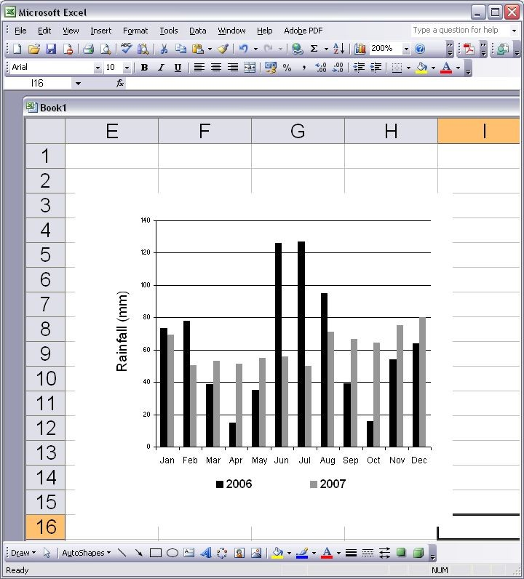

Figure 1. Monthly Rainfall in Semarang, 2006 and 2007 (International Daylight Monitoring Programme, 2008) [Title of Figure: Calibri 8pt]

Reference
Cite the main scientific publications on which your work is based. Cite only items that you have read. Please refer to APA 6th Edition Format to write the references. Check each reference against the source (author's name, volume, issue, year). Please use Reference Manager Applications like EndNote, Mendeley, etc. All publications cited in the text should be included as references. Please ensure that every reference cited in the text is also in the reference list (and vice versa).
The reference/bibliography is a minimum 25 items from a journal or conference proceeding. Exclude Report, Thesis, Book, or website.

